Sacrament of Penance
Wednesday ~ 6:00 - 7:00 pm; or by appointment.

Sacrament of the Sick
Anointing of the Sick should be given if an individual is gravely ill or near death. If possible, the Sacrament should also be administered before major surgery or when one is initially hospitalized.

Sacrament of Holy Matrimony
Diocesan policy requires 12 months of preparation for Marriage. Contact the parish as soon as possible after engagement. No arrangements should be made prior to consultation with the pastor.

Sacrament of Baptism
Parents must be registered members of the parish and attend a Baptism preparation class prior to the Baptism if this is your first child baptized. Requirements for godparents are established by the Catholic Church. Please call the parish office for Information and to register your child for Baptism.

Parish Registration
All Catholics should be registered in their local parish. Please contact the parish office to obtain registration forms, or if you are uncertain of the parish where you should register.

Parish Staff & Ministries Directory
Financial Manager ~ Richard Deardorff ~ 717- 677-8012 or 717-420-3464 (cell)
rdeardorff@hbgdiocese.org
Director of Religious Education ~ Deacon Steve Huete ~ shuete@hbgdiocese.org
Administrative Assistant ~ Kristen DiDio ~ kdidio@hbgdiocese.org
Buildings & Grounds ~ JB Groff ~ 717-677-8012
Music Ministry ~ Phil Mobley ~ 717-677-8012
Parish Council Members
Kathleen Allwein
Donnie Althoff
Charlie Baker
Jim Bittle
Mike McTighe
Joanne Riedel - Secretary
Walt Wilson - Chair

Finance Council Members
Richard Deardorff (Ex Officio)
Greg Ernst - Chair
Alix Haller
Christy Hemler - Secretary
Terri Pendlelton
Bill Pulig

Prayer Chain
Lynne Mobley at LMOBLEY509@gmail.com
or 703-876-4901.

Soup Kitchen
Please send donations directly to “Soup Kitchen”

Website Development
Kristen DiDio
Life After Loss
Dodie Huete

OCIA
Contact Fr. Dominic

Picnic Co-Chairpersons
John Neiderer
Wally Kane

Pro-Life Ministry
OPEN – Contact office if you are interested

Knights of Columbus
SK Bob Ternes
- Grand Knight

Covid-19 Task Force
Walt Wilson - Coordinator
Health Advisors:
Dr. Robert Ternes and
Joanne Cochran
(Keystone Health System)

Altar Flowers
OPEN - Contact office if you are interested

Bereavement Ministry
Ginny Bittle

Catholic Communications/EWTN
Open - Contact office if you are interested

Cemetery
Contact Parish Office
Diocese of Harrisburg Youth Protection Program
www.YouthProtectionHBG.com
Abuse Reporting Contact Information:
First – Call the toll-free PA Child Abuse Hotline at 800-932-0313
Then – Call the Diocesan toll-free hotline at 800-626-1608

“If one member suffers,
all suffer together with it.” (1 Cor 12:26)

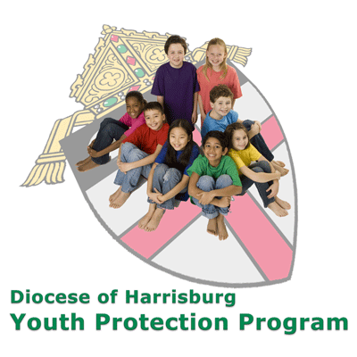

St. Ignatius Loyola RC Church

1095 Church Road, Orrtanna, Pennsylvania 17353

January 8, 2023: EPIPHANY OF THE LORD

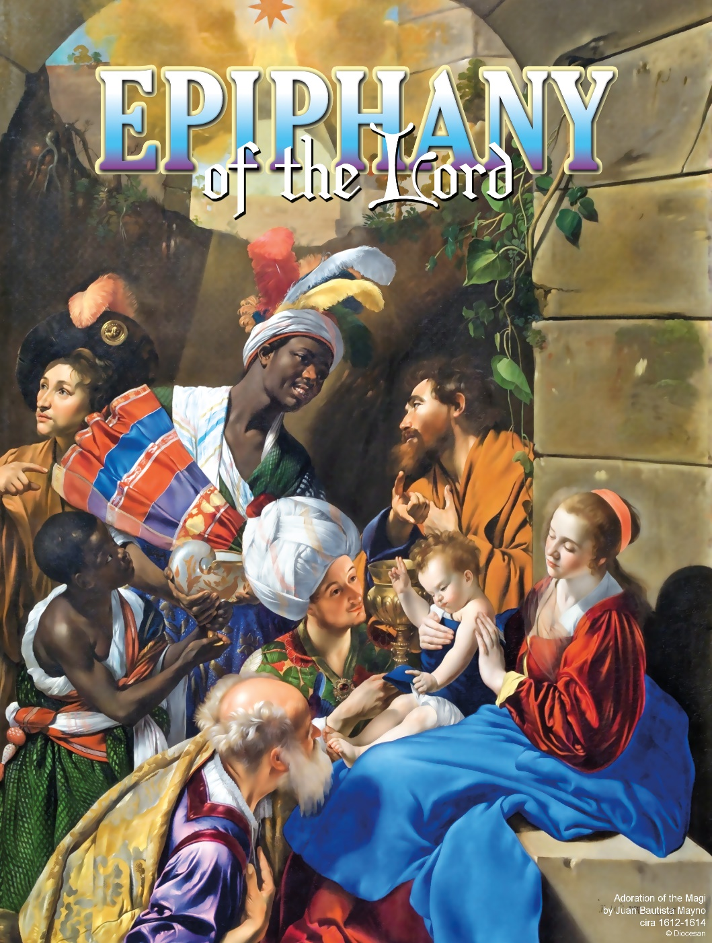

Most Reverend Ronald W. Gainer, Bishop of Harrisburg;
Rev. Dominic M. DiBiccaro, Pastor / Deacon Steve Huete, Pastoral Associate
Mass Schedule, Intentions, and Events
Please Pray for:
Coronavirus victims and those who are ill, Jim & Jeanie Kline, Mrs. Kelly Kump, Ron Thumma, Joe and Diane Wisotzkey, Leo Hockensmith, Erika McKissick, Jean "Heather" O'Shea, Scott Moore and Sally Moore, Mary Wyatt, Jim & Joyce Deardorff, Brandon & Michelle Gilbert, Amy Weatherup, Sophia Joy Ernst, Mary & Chuck Irwin, Deacon Richard Wentzel, Deacon Frank Enderle, Marie Kalp, Kathleen Thompson, Deb & Kathy McLintock and Family, Rachel Wonders, Amy Edwards, Jean O’Connor, Art Lazar, Sr., Mark & Michelle Huete, Paul Angello, Jen Baldwin, Ursula Kaley, Deb Bennet, Fr. Bill Sullivan, Fr. Chet Snyder, John Larry Endy, Mary Beth McCarthy, Laura Lee, Marwa Abdelrahman, Cathy Gates, Donna Singley, Jack Ryff, Tim McGinn, Jane Kump, Gary, Bill, Jerry, Andy, Colleen, Baby Addie, Peggy Neiderer, Chris Kimple, Robert Riquet, Gene & Jo-Ann McDannell, Bob Doxzen, Kimberly Mears, Gabriella Angello, Mark & Kate Morrow, Mark Morris, Linda Fogleman, Paul Knight, George & Barbara Erstila, Jeff Carpenter, Lana & Nelson Harmon, Cole & Connor, Diane Slothour, Sue McDannell, Larry Schneider, Joe & Lisa Grasel, Ange Pena, Julie Barnhart, the Shaffer Family, Heather & Emma Dickerson, Brad Pabody, Adeline Lienard, Robbie, Michael & daughter, Paul Ward, Aiden Tyler Schneider, Dorothy Vega, Karrie McCall & daughter, George Shahid, Denise Navlyt, Drew Schneider & Family, Ida Bloomfield, Linda McDannell, Janie Singley, Mary Beth Greenstreet, Rick Benedict, Jan Patla, Kathe Fogleman, Sam Sheffler, Kate Hemmis, Bill & Mary Lou Graham, Joanna Hodges, John Varones, Joan O’Sullivan, Martha Klinger, Lisa Dionne Lauretti, Sue Orndorff, Jim Gleason, Sue Gustafson, Joe & Michelle Cleary, Kim Johnson, Helen Mills, Kathy Haber, Haley Detman, Joe Durovey, Bev Smith, Donald Sheppard, Linda Mumaugh, Alison Haring, Janet Hartman, Edward Johnson, Angela Galeone, Juliete Lang, Chris MacBeth, Harry Graham, Donald Howard, Armond Binni, Elizabeth Stansky, Pat Johnson, Chris Morris, Faud Doaney, Rae Harmand, Patrick Glass, Helen Lagasse, Nancy Kewisnek, Andy Graham, Bill & Maureen Collins, Rosemary McGilloway, Anji Eisenhart, Monica Manner, Denny Borbonus, Dr. Paul Scarlata, Mary Hawthorne, Ed Washington, Josh Kempinski, Nancy Baker Baltzey, Spencer Propts, Karlton Smith & Cheryl Sobun, James & Marylyn Sobun, Marlene Webster, Yvette Stoklosa, Andy Consiglio, Bill & Michelle Cloonan, Nelson Salem, Janet Shunnarah, George Shunnarah, Bill & Deb McClintock, Mary Pekich, nursing home residents & shut-ins, the victims of war, violence, disease, disaster, & all private intentions.

Also In your prayers, please remember all our men and women currently serving in our Armed Forces:
Maj. Nathan Jeffcoat – US Marine Corps
Lt. Alexandra Jeffcoat – US Navy
Lt. Joseph Cleary – US Navy
Michael C. Kenney IV – US Coast Guard
Lt. Joshua Kimple – US Army
and Lt. Sarah Fogleman, M.D. – US Navy

PRAYER CHAIN: Contact Lynne Mobley at LMOBLEY509@gmail.com or 703-876-4901.

for the Week of January 7 ~ January 15, 2023

SATURDAY, January 7 - VIGIL MASS for the EPIPHANY of the LORD

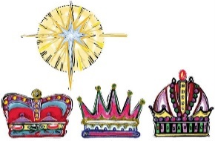
Is 60:1-6 / Eph 3:2-3a, 5-6 / Mt 2:1-12
5:00PM + Frank Charles Hagan

SUNDAY, January 8 – THE EPIPHANY

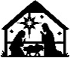
Is 60:1-6 / Eph 3:2-3a, 5-6 / Mt 2:1-12 OF THE LORD
8:00AM + Linda Sluck
10:30AM - People of the Parish

Monday, January 9 - THE BAPTISM OF THE LORD
Is 42:1-4, 6-7 or Acts 10:34-38 / Mt 3:13-17
10:00AM + Pope Benedict XVI [Mass added this week only]
Parish Office Closed

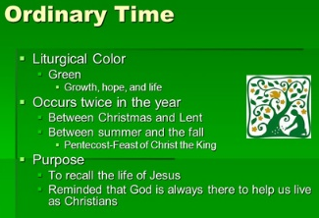
Tuesday, January 10 (First Week in OT)
Heb 1:1-6 & 2:5-12 / Mk 1:14-20 & 1:21-28
10:00AM + Julia Weishaar

11:00AM: “Something More” Faith Group

6:30PM: Parish Council

Wednesday, January 11 (Weekday in OT)
Heb 2:14-18 / Mk 1:29-39

8:00AM - 3:00 PM ~ Office Open

10:00AM: Senior Spirituality Group
- - - - - - - - - - - - - - - - - - - - - - - - - - - - - - - - - - - - - - - - - - - - - - - - -
7:00PM + Ruth Ann Robinson
Confessions heard from 6-6:45PM; Adoration 7:40–8PM
Thursday, January 12 (Weekday in OT)
Heb 3:7-14 / Mk 1:40-45
8:00AM - 3:00 PM ~ Office Open
10:00AM + Judith Weaver

Friday, January 13 – St. Hilary of Poitiers, Bishop &
Heb 4:1-5, 11 / Mk 2:1-12 Doctor of the Church
10:00AM + Margaret Gracyalny
Parish Office CLOSED

Saturday, January 14 (Weekday in OT)

MORNING: Heb 4:12-16 / Mk 2:13-17

SATURDAY, January 14-VIGIL MASS 2nd SUNDAY ORDINARY TIME

Is 49:3, 5-6 / 1 Cor 1:1-3 / Jn 1:29-34
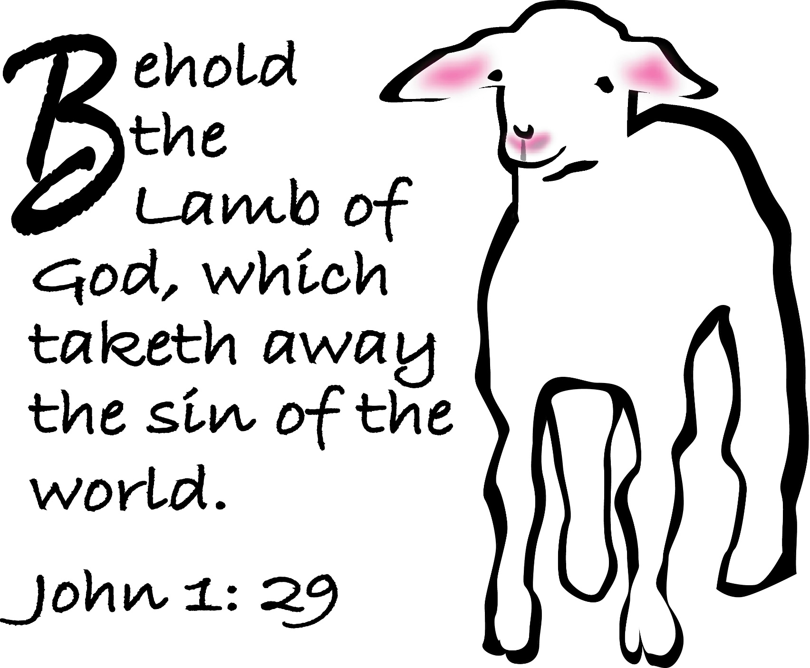
5:00PM + Terry Acciarri
SUNDAY, January 15 – 2ND SUNDAY OT

Is 49:3, 5-6 / 1 Cor 1:1-3 / Jn 1:29-34
8:00AM ~ People of the Parish
10:30AM + Joseph Miller

Sanctuary candle offered for JANUARY: In loving memory of Marilyn Cole from Ken Cole and Family
Sunday Collection Summary
Sunday Collection Summary
December 31,2022 & January 1, 2023

Weekend Collection
Regular Offering/Mary, MOG Holy Day $ 3,808.00
Candles/Living Faith $ 76.55
TOTAL OFFERINGS $ 3,884.55
Donation letters for the 2022 TAX YEAR will be available upon request from the Parish Office by the end of January 2023.

Other Income
Individual Contribution $ 200.00
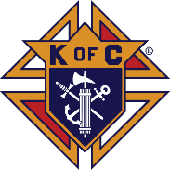
Total Offering $ 4,084.55
WEEKLY BUDGETARY NEEDS $ 4,655.68
+Overage or (Shortfall) for the month ($ 571.13)
Memorial Donations (Redding) $ 20.00
Cemetery Plot Sales $ 720.00
Advoca​cy & Protection
To Empower Citizens with Intellectual and Developmental Disabilities
FREE-WILL OFFERING IN NARTHEX
The weekends of Jan.14/15, 21/22, & 28/29

Christmas (Dec. 18 collection) $ 5,500.00
Christmas (Dec. 25 collection $ 3,979.00
Christmas (Jan 1. collection) $ 425.00
Total Christmas offerings to date $ 9,904.00
– BUDGETED CHRISTMAS COLLECTION $ 8,715.00
+Overage or (Shortfall) to budget + 1,189.00

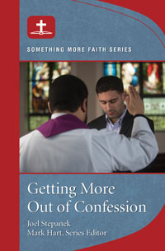
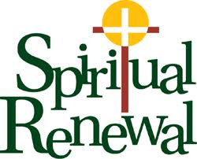

Open Your Heart, Listen to God

God always has more for us-more of His love, more of His grace, more of His peace.
How can we be open to receiving these gifts – especially as we continue in this Year
of our NATIONAL EUCHARISITIC REVIVAL? Come and see!

NEXT UP in the "Something More" Faith Series:

Getting More Out of CONFESSION

Tuesdays, 11AM, Starting Jan. 10 to Feb. 7

January 22 – Sunday of the Word of God
January 22 – 2nd Collection: Cemetery Upkeep
February 5 – World Missions MEMBERSHIP SUNDAY
February 12 – 2nd Collection: Black & Indian Missions
February 22 – ASH WEDNESDAY

Falling in Love with a Whom, Not Just a What
December 9, 2022 | Adam LaCrosse

I have always considered myself a bookworm, or to be more precise, a knowledge-worm. Growing up with a physical handicap — cerebral palsy — meant that the gifts and talents God gave me were much better suited to the library than athletics. Thank God for that, because I am not very fast! Life was always better for me when I had a book to read, and I soaked up my religious education classes with the same enthusiasm and vigor I did for all my other school subjects. I was proud to be the one with the answers, the one that people turned to when they had questions about the Catholic Church. But, after I graduated college, something did not feel quite right with my prayer life. I asked God about it, and He answered with a revelation that shook me to my core.

Knowledge was great, but He was calling me deeper. To put it another way, I knew a lot about Jesus, but I really did not really know Jesus on a personal level. That was a major problem. After all, St. Peter was not going to be standing there on my judgment day with a multiple-choice quiz about Catholic doctrine! Something had to be done — or, rather, I had to really meet Someone …

This is my Body, this is my Blood

As it happened, I had been going through a dry spell in my faith, seeing Catholicism as just a set of things to believe, without any bearing on the real struggles and questions that are so prevalent today, especially, “Where does my dignity come from, and can it ever be taken away?” Turning to the Gospels for comfort, I read with a new intention. I wanted to get to know Christ as a human person, not just as a God whose commands had to be rightly followed. Surprisingly, something clicked. When Christ spoke The Words of Institution at the Last Supper, He kept referring to the word this. This is my Body; this is my Blood. It was in that moment of rereading those words that I had heard so often at Mass that the words finally went from my head to my heart. Here He was, Jesus, the great man both fully human and fully Divine. He was inviting me to get out of my head, stop treating my faith as just an intellectual exercise, and connect on a heart level.

That weekend at Mass, I experienced the Eucharist in a whole new light. It was one thing to constantly be told that I truly was receiving Jesus’s Body and Blood, but it was another thing entirely to accept that in my heart.
Here I was, a sinner just like everyone else, grateful to receive Jesus not just as a great teacher, but as the God-man who lived, died, and rose, for me. I could taste the one who poured out every drop of blood He had for me. I became His tabernacle, and His Presence filled every part of me.

Limitless Love

The Eucharist is the closest thing to perfect happiness on this side of Heaven for me. I am now more confident than I have ever been in God’s limitless love for me, and I yearn to share that love with everyone.
Understanding the awesome gift of the Eucharist as a loving union with Christ, has strengthened me to strive to become a more faithful member of His Body, the Church. Because of this, I can more joyfully bring Christ to others.
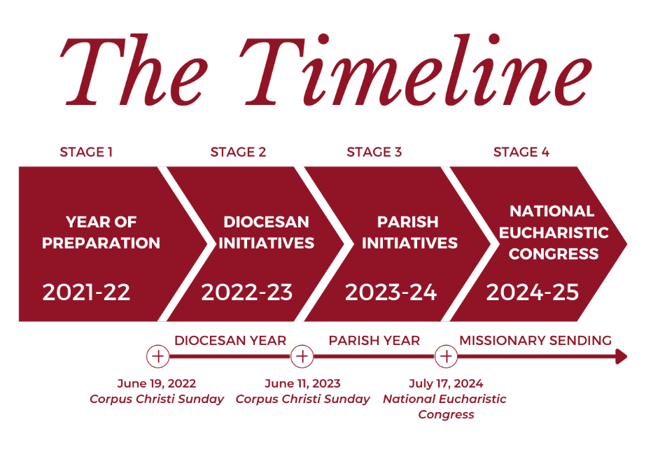

The Holy Father, Pope Francis’ Prayer Intentions for 2023
Entrusted to His Worldwide Prayer Network
JANUARY ~ For educators
We pray that educators may be credible witnesses, teaching fraternity rather than competition, and helping the youngest and most vulnerable above all.

A King to Behold: Scott Hahn Reflects

on the Epiphany of the LORD

An “epiphany” is an appearance. In today’s Readings, with their rising stars, splendorous lights, and mysteries revealed, the Face of the Child born on Christmas Day appears.

Herod, in today’s Gospel, asks the chief priests and scribes where the Messiah is to be born. The answer Matthew puts on their lips says much more, combining two strands of Old Testament promise — one revealing the Messiah to be from the line of David (see 2 Samuel 2:5), the other predicting “a ruler of Isra-el” who will “shepherd His Flock” and whose “greatness shall reach to the ends of the earth” (see Micah 5:1–3).

Those promises of Isra-el’s king ruling the nations resound also in today’s Psalm. The psalm celebrates David’s son, Solomon. His kingdom, we sing, will stretch “to the ends of the earth,” and the world’s kings will pay him homage. That’s the scene too in today’s First Reading, as nations stream from the East, bearing “gold and frankincense” for Isra-el’s king.

The Magi’s pilgrimage in today’s Gospel marks the fulfillment of God’s promises. The Magi, probably Persian astrologers, are following the Star that Balaam predicted would rise along with the ruler’s staff over the house of Jacob (see Numbers 24:17).

Laden with gold and spices, their journey evokes those made to Solomon by the Queen of Sheba and the “kings of the earth” (see 1 Kings 10:2, 25; 2 Chronicles 9:24). Interestingly, the only other places where frankincense and myrrh are mentioned together are in songs about Solomon (see Song of Songs 3:6; 4:6, 14).

One “greater than Solomon” is here (see Luke 11:31). He has come to reveal that all peoples are “co-heirs” of the royal family of Isra-el, as today’s Epistle teaches.

His manifestation forces us to choose: will we follow the signs that lead to Him as the wise Magi did? Or will we be like those priests and scribes who let God’s words of promise become dead letters on an ancient page?
Readings: Isaiah 60:1–6; Psalm 72:1–2, 7–8, 10–13; Ephesians 3:2–3, 5–6; Matthew 2:1–12
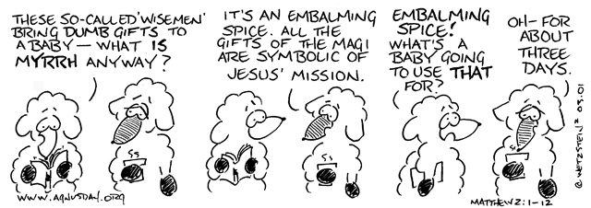

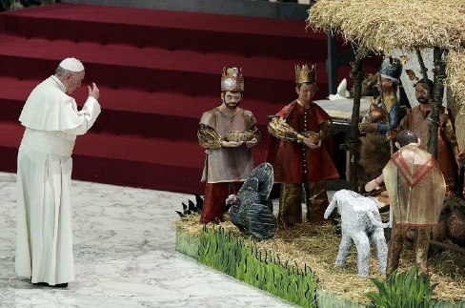
When to Take Down the

Christmas Crib/Manger/Decorations

ZENIT December 15, 2015 | by Fr. Edward McNamara

Answered by Legionary of Christ Father Edward
McNamara, professor of liturgy and dean of theology
at the Regina Apostolorum University.

Q: My question is simple but causes confusion among us
sometimes: When should the crib/Nativity scene come down
in the church? Should it happen before the Baptism of the LORD or afterward?

A: This and similar questions arise almost every year around this time, so some of what we say now has already been published in earlier pieces. There is not a great deal of what could be deemed “magisterium” on the Christmas crib and other Christmas traditions. Most such traditions are customary and hence are not determined in official norms. Since legitimate varieties in customs do exist, there is not necessarily a right or a wrong answer to this question.

With respect to the question as to when to remove the crib, once more customs vary from place to place, and there is no absolute rule. In some places it may be customary to remove the crib after the Epiphany. In others, and perhaps more commonly, after the feast of the Baptism of the LORD, which marks the end of the official Christmas Season in the current calendar.

This feast is usually the Sunday after the Epiphany. However, in those countries that transfer the Epiphany to the Sunday between Jan. 2 and 8, the feast is celebrated on a Monday, Jan. 9, whenever Christmas Day falls on a Sunday and Epiphany falls on Jan. 8. In this case the Christmas season ends on Monday instead of Sunday.

In some countries it is not unusual to retain some Christmas decorations until the feast of the Presentation of the LORD on February 2. [In fact, Saint] John Paul II would make his last visit to the crib in St. Peter’s Square after celebrating the evening Mass on Feb. 2. After this visit the Nativity scene was [then] dismantled. [EA]

This corresponds to a longstanding custom in which the eve of Candlemas [the Presentation] was the day for removal of Christmas decorations, especially those made of greenery. This tradition is witnessed by poet Robert Herrick (1591-1654) in two of his poems, one of them “Ceremony upon Candelmas Eve”:

“Down with the rosemary, and so Down with the bays and mistletoe; Down with the holly, ivy, all, Wherewith ye dress’d the Christmas Hall.”

He takes up a similar theme in the first verses of his longer verse, “Ceremonies for Candlemas Eve”:

“Down with the rosemary and bays, Down with the mistletoe; Instead of holly, now up-raise, The greener box (for show). The holly hitherto did sway; Let box now domineer, Until the dancing Easter day, Or Easter’s eve appear.”

Therefore, at the risk of furthering a state of confusion, I can only say that the best option is to maintain what is already customary in each place.
