Sacrament of Penance
Wednesday ~ 6:00 - 7:00 pm; or by appointment.

Sacrament of the Sick
Anointing of the Sick should be given if an individual is gravely ill or near death. If possible, the Sacrament should also be administered before major surgery or when one is initially hospitalized.

Sacrament of Holy Matrimony
Diocesan policy requires 12 months of preparation for Marriage. Contact the parish as soon as possible after engagement. No arrangements should be made prior to consultation with the pastor.

Sacrament of Baptism
Parents must be registered members of the parish and attend a Baptism preparation class prior to the Baptism if this is your first child baptized. Requirements for godparents are established by the Catholic Church. Please call the parish office for Information and to register your child for Baptism.

Parish Registration
All Catholics should be registered in their local parish. Please contact the parish office to obtain registration forms, or if you are uncertain of the parish where you should register.

Parish Staff & Ministries Directory
stignatiusofloyola@hbgdiocese.org
Financial Manager ~ Richard Deardorff ~ 717- 677-8012 or 717-420-3464 (cell)
rdeardorff@hbgdiocese.org
Director of Religious Education ~ Deacon Steve Huete ~ shuete@hbgdiocese.org
Administrative Assistant ~ Kristen DiDio ~ kdidio@hbgdiocese.org
Buildings & Grounds ~ JB Groff ~ 717-677-8012
Music Ministry ~ Phil Mobley ~ 717-677-8012
Parish Council Members
*Walt Wilson – Chair 401-0570 (h) wwilson1198@comcast.net
Joanne Riedel - Secretary 398-2021 (h) sterj221@aol.com
Kathi Allwein 677-8984 (h) allweint@comcast.net
*Donnie Althoff 339-6527 (c) dalthoff53@gmail.com
Charlie Baker 677-9536 (h) dcbake@embarqmqil.com
*Jim Bittle 677-6711 (h) ginnybittle@comcast.net
Mike McTighe 729-6239 (c) mike0432@aol.com

Finance Council Members
Richard Deardorff (Ex Officio)
Greg Ernst - Chair
Alix Haller
Christy Hemler - Secretary
Terri Pendlelton
Bill Pulig

Altar Flowers
Prayer Chain
Lynne Mobley at LMOBLEY509@gmail.com
or 703-876-4901.

Soup Kitchen
Please send donations directly to “Soup Kitchen”

Website Development
Kristen DiDio
Life After Loss
Dodie Huete

OCIA
Contact Fr. Dominic

Picnic Co-Chairpersons
John Neiderer
Wally Kane

Pro-Life Ministry
OPEN – Contact office if you are interested

Knights of Columbus
SK Bob Ternes
- Grand Knight

Covid-19 Task Force
Walt Wilson - Coordinator
Health Advisors:
Dr. Robert Ternes and
Joanne Cochran
(Keystone Health System)

OPEN - Contact office if you are interested

Bereavement Ministry
Ginny Bittle

Catholic Communications/EWTN
Open - Contact office if you are interested

Cemetery
Contact Parish Office
THEOSIS Ministry
Kathy Dietsch 717-352-4558
Bicky Redman 717-677-8592

Diocese of Harrisburg Youth Protection Program
www.YouthProtectionHBG.com

Abuse Reporting Contact Information:
First – Call the toll-free PA Child Abuse Hotline at 800-932-0313
Then – Call the Diocesan toll-free hotline at 800-626-1608

“If one member suffers,
all suffer together with it.” (1 Cor 12:26)

St. Ignatius Loyola RC Church

1095 Church Road, Orrtanna, Pennsylvania 17353
www.stignatiusofloyola.org

March 19, 2023: FOURTH SUNDAY of LENT

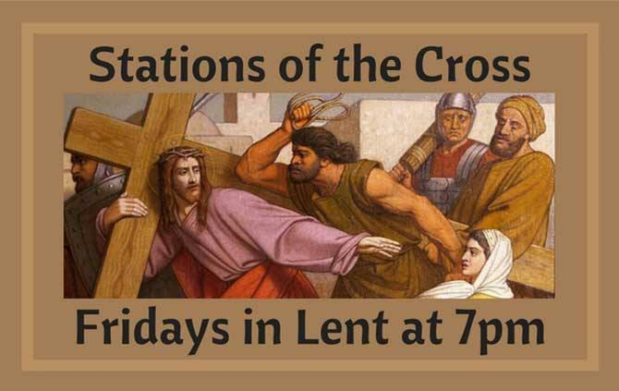

Most Reverend Ronald W. Gainer, Bishop of Harrisburg;
Rev. Dominic M. DiBiccaro, Pastor / Deacon Steve Huete, Pastoral Associate
Mass Schedule, Intentions, and Events
Please Pray for:
Coronavirus victims and those who are ill, Jim & Jeanie Kline, Kaylee Henry, Chuck & Nancy Wuller, Dr. Mike Colli, Mrs. Kelly Kump, Kevin & Brittany Groff, Gabriel Singer, Sharon McCormley, Ron Thumma, Joe Wisotzkey, Leo Hockensmith, Erika McKissick, Jean "Heather" O'Shea, Scott Moore and Sally Moore, Mary Wyatt, Jim & Joyce Deardorff, Brandon & Michelle Gilbert, Amy Weatherup, Sophia Joy Ernst, Mary & Chuck Irwin, Deacon Richard Wentzel, Deacon Frank Enderle, Kathleen Thompson, Deb & Kathy McLintock and Family, Rachel Wonders, Amy Edwards, Jean O’Connor, Art Lazar, Sr., Mark & Michelle Huete, Paul Angello, Jen Baldwin, Ursula Kaley, Deb Bennet, Fr. Bill Sullivan, Fr. Chet Snyder, John Larry Endy, Mary Beth McCarthy, Laura Lee, Marwa Abdelrahman, Cathy Gates, Donna Singley, Jack Ryff, Tim McGinn, Jane Kump, Gary, Bill, Jerry, Andy, Colleen, Baby Addie, Peggy Neiderer, Chris Kimple, Robert Riquet, Gene & Jo-Ann McDannell, Bob Doxzen, Kimberly Mears, Gabriella Angello, Mark & Kate Morrow, Mark Morris, Linda Fogleman, Paul Knight, George & Barbara Erstila, Jeff Carpenter, Lana & Nelson Harmon, Cole & Connor, Diane Slothour, Sue McDannell, Larry Schneider, Joe & Lisa Grasel, Ange Pena, Julie Barnhart, the Shaffer Family, Heather & Emma Dickerson, Brad Pabody, Adeline Lienard, Paul Ward, Aiden Tyler Schneider, Dorothy Vega, Karrie McCall & daughter, George Shahid, Denise Navlyt, Drew Schneider & Family, Ida Bloomfield, Linda McDannell, Janie Singley, Mary Beth Greenstreet, Rick Benedict, Jan Patla, Kathe Fogleman, Sam Sheffler, Kate Hemmis, Bill & Mary Lou Graham, Joanna Hodges, John Varones, Joan O’Sullivan, Martha Klinger, Lisa Dionne Lauretti, Sue Orndorff, Jim Gleason, Sue Gustafson, Joe & Michelle Cleary, Kim Johnson, Helen Mills, Kathy Haber, Haley Detman, Joe Durovey, Bev Smith, Donald Sheppard, Linda Mumaugh, Alison Haring, Janet Hartman, Edward Johnson, Angela Galeone, Juliete Lang, Chris MacBeth, Harry Graham, Donald Howard, Armond Binni, Elizabeth Stansky, Pat Johnson, Chris Morris, Faud Doaney, Wilson & Rae Harman, Patrick Glass, Helen Lagasse, Nancy Kewisnek, Andy Graham, Bill & Maureen Collins, Rosemary McGilloway, Anji Eisenhart, Monica Manner, Denny Borbonus, Dr. Paul Scarlata, Mary Hawthorne, Ed Washington, Josh Kempinski, Nancy Baker Baltzey, Spencer Propts, Karlton Smith & Cheryl Sobun, James & Marylyn Sobun, Marlene Webster, Yvette Stoklosa, Andy Consiglio, Bill & Michelle Cloonan, Nelson Salem, Janet Shunnarah, George Shunnarah, Bill & Deb McClintock, Mary Pekich, nursing home residents & shut-ins, the victims of war, violence, disease, disaster, & all private intentions.
Also In your prayers, please remember all
our men and women currently serving in
our Armed Forces:
Maj. Nathan Jeffcoat – US Marine Corps
Lt. Joseph Cleary – US Navy
Michael C. Kenney IV – US Coast Guard
Lt. Joshua Kimple – US Army
Lt. Sarah Fogleman, M.D. – US Navy

PRAYER CHAIN: Contact Lynne Mobley at
703-876-4901 or LMOBLEY509@gmail.com

for the Week of March 11 to March 19, 2023

SATURDAY, March 18 - VIGIL MASS 4th SUNDAY OF LENT

1 Sm 16:1b, 6-7, 10-13a / Eph 5:8-14 / Jn 9:1-41
5:00PM + Marilyn Cole
SUNDAY, March 19 – 4th SUNDAY OF LENT

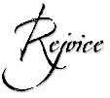
1 Sm 16:1b, 6-7, 10-13a / Eph 5:8-14 / Jn 9:1-41
8:00AM + Charles Heffner
10:30AM ~ People of the Parish

Monday, March 20–SOLEMNITY OF ST. JOSEPH,
2 Sm 7:4-5a, 12-14a, 16 / HUSBAND OF MARY
Rom 4:13, 16-18, 22 /Mt 1:16, 18-21, 24a
10:00AM + Bishop Daniel O’Connell
Parish Office Closed

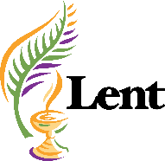
Tuesday, March 21 (Lenten Weekday)
Ez 47:1-9, 12 / Jn 5:1-16
8:00AM - 3:00 PM ~ Office Open
10:00AM - Spec. Int. for Bill & Mary Lou Graham

11:00AM:“Something More” Faith Group

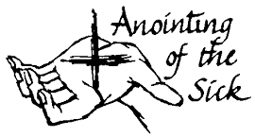
Wednesday, March 22 (Lenten Weekday)
Is 49:8-15 / Jn 5:17-30

8:00AM - 3:00 PM ~ Office Open

11:00AM Senior Spirituality Group
NO Confessions
NO Adoration
7:00PM + Joanne Esham
Anointing of the Sick within Mass
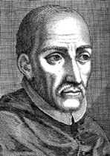
Thursday, March 23 – St. Turibius of Mogrovejo
Ex 32:7-14 / Jn 5:31-47
8:00AM - 3:00 PM ~ Office Open
10:00AM - Private Intention

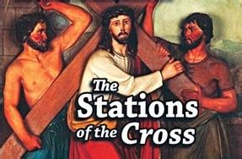
Friday, March 24 (Lenten Weekday)
Wis 2:1a, 12-22 / Jn 7:1-2, 10, 25-30
10:00AM + Trish Weishaar
Parish Office CLOSED
7:00PM Stations of the Cross
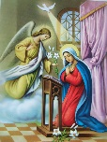

Saturday, March 25 – SOLEMNITY OF

THE ANNUNCIATION

10:00AM– Spec. Int. Sr. Thelma Steiger & Sr. Jo Ann Knight

SATURDAY, March 25 - VIGIL MASS 5th SUNDAY OF LENT

Ez 37:12-14 / Rom 8:8-11 / Jn 11:1-45
5:00PM + Jack Hoctor
SUNDAY, March 26 – 5th SUNDAY OF LENT

Ez 37:12-14 / Rom 8:8-11 / Jn 11:1-45

8:00AM ~ People of the Parish
10:30AM + Refugio Vega
Sanctuary candle offered for MARCH: In loving memory of KEN SWARTZ from Lena Swartz and family
Sunday Collection Summary
March 11 & 12

2023 HERSHEY PARK DISCOUNT TICKETS
ARE NOW AVAILABLE!
Pick up an Order Form in the Narthex of the Church, fill out and return with your payment. You may drop off in the office or place in an envelope and drop in the collection basket (marked Hershey Park, office)
NO LATER THAN MARCH 26th.
Ticket Prices
Purchase before March 26th, 2023: $42.95
(Regular price $85.80)
Tickets valid April - January 1, 2024
OR $40.95 (Regular price $85.80)

Single-Use Meal Plan Prepaid Parking Passes
$14.99 (reg. price $16.95) $20.00 (pre-purchase only
Weekend Collection
Regular Offering $ 2,907.00
Candles $ 47.00
Easter Flowers $ 688.00
Local Poor $ 25.00
TOTAL OFFERINGS $ 3,667.00

‒WEEKLY BUDGETARY NEEDS $ 5,819.68
+Overage or (Shortfall) for the week ($ 2,152.68)

Other Income
Deposit to Savings $ 10,000.00
Insurance Claim Refund $ 450.00
Memorial Marie Kalp $ 100.00
Fish Dinner (Gross) $ 95.00
TOTAL OTHER OFFERINGS $ 10,645.00

Diocesan Second Collections
Catholic Relief Services $ 250.00
Propagation of Faith $ 20.00
REMINDER: Members of the Parish THEOSIS Ministry have available hours to offer those who need transportation: to/from Mass; doctor appointments; prescription pick-up; grocery shopping; or other local errands. Please call the Parish Office for further information.

TOTAL DIOCESAN OFFERINGS $ 270.00
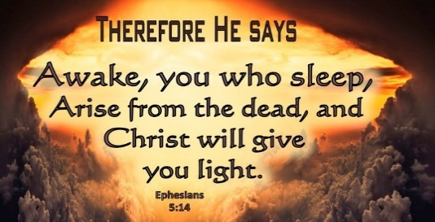

DIOCESAN ANNUAL CAMPAIGN UPDATE
Parish Goal for 2023: $ 29,847.61
Total Paid (as of 2/28/23): $ 6,399.00
Outstanding Pledges: $ 325.00
Total Committed: $ 6,724.00
Over/(under)goal in cash: ($23,448.61)
Shortfall Payments: n/a
Pledges written off: n/a
% toward goal cash rec’d: 21.44%
Average per donor: $ 319.95
Number of Donors: 20
Registered Households: 270
Percentage of Participation: 7.41%

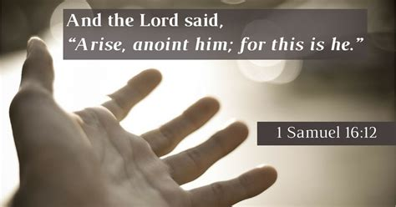

March 22 – Anointing of the Sick within Mass, 7PM
March 26 – 2nd Collection: CATHOLIC RELIEF SERVICES
March 26 – Penance Service, 3PM, Corpus Christi, Chmbg.

March 29 – Penance Service, 7PM, Corpus Christi, Chmbg.

March 31 – SOUP & BREAD SUPPER, 5PM BEFORE Stations

St. Ignatius Loyola Parish will hold our

Easter Ham Bingo
on
Monday, April 3, 2023.

Doors will open at 5:00 p.m.
& bingo will begin at 6:30 p.m.

Admission is $25 for 35 games.
Raffles, door prizes, food, and MUCH MORE!

For more information,
please contact Diane at 717-677-9352.

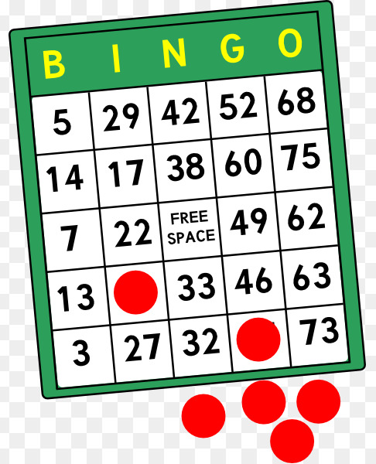

The Holy Father, Pope Francis’ Prayer Intentions for 2023
Entrusted to His Worldwide Prayer Network
MARCH ⁓ For victims of abuse
We pray for those who have suffered harm from members of the Church; may they find within the Church Herself a concrete response to their pain and suffering.

Eyesight to the Blind: Scott Hahn Reflects

on the Fourth Sunday of Lent

God’s ways of seeing are not our ways, we hear in today’s First Reading. Jesus illustrates this in the Gospel as the blind man comes to see and the Pharisees are made blind.

The blind man stands for all humanity. “Born totally in sin,” he is made a new creation by the saving power of Christ.

As God fashioned the first man from the clay of the earth (see Genesis 2:7), Jesus gives the blind man new life by anointing his eyes with clay (see John 9:11). As God breathed the spirit of life into the first man, the blind man is not healed until he washes in the waters of Siloam, a name that means “Sent.”

Jesus is the One “sent” by the Father to do the Father’s Will (see John 9:4; 12:44). He is the new source of life-giving water: the Holy Spirit who rushes upon us in Baptism (see John 4:10; 7:38–39).

This is the Spirit that rushes upon God’s chosen king David in today’s First Reading. A shepherd like Moses before him (see Exodus 3:1; Psalm 78:70–71), David is also a sign pointing to the “good shepherd” and “king to come” — Jesus (see John 10:11).

The LORD is our shepherd, as we sing in today’s Psalm. By His death and Resurrection He has made a path for us through the dark valley of sin and death, leading us to the verdant pastures of the Kingdom of Life, the Church.

In the restful waters of Baptism He has refreshed our souls. He has anointed our heads with the oil of Confirmation and spread the Eucharistic Table before us, filling our cups to overflowing.

With the once-blind man we enter His House to give God the praise, to renew our vow: “I do believe, LORD.”

“The LORD looks into the heart,” we hear today. Let Him find us, as St. Paul advises in today’s Epistle, living as “children of light,” trying always to learn what is pleasing to our Father.

Readings: 1 Samuel 16:1, 6–7, 10–13; Psalm 23:1–6; Ephesians 5:8–14; John 9:1–41

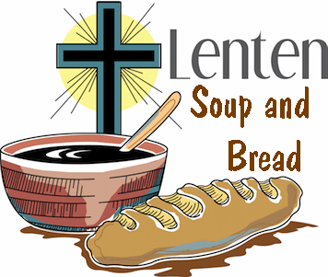

“Breaking Bread Together”

Chowder & Soup Night
Friday, March 31, 2023
5:00 to 6:30pm

Clam Chowder & Soups (MEATLESS)
Caesar Salad
Homemade Italian Bread
Brownies and Cookies
Hot Cocoa, Coffee, Tea & Water

FREE-WILL DONATIONS ACCEPTED!
Proceeds go to the Gettysburg Community Soup Kitchen

{So sorry, but no takeout is available}

THEN everyone is invited to stay after for the 7PM
Stations of the Cross
7:00 pm
Questions? Please contact:
Judy
717-443-3139 or Kathy
717-352-4558

St Ignatius Loyola Catholic Church
1095 Church Rd. Orrtanna, PA

Eucharistic Prayer Companion for Fourth Sunday of Lent: Jesus Heals

March 14, 2023 | Eucharistic Revival Team

This Eucharistic Meditation is designed to help you spend 30 minutes to an hour in meditation and silent prayer with Jesus during Eucharistic adoration. Even if you cannot be physically present in a church or adoration chapel with the Blessed Sacrament, you can unite yourself spiritually to the Eucharist as you spend this time in prayer.

THE GRACE I SEEK: to believe that Jesus longs to bring me healing and strength

‍‍+ IN THE NAME OF THE FATHER, AND OF THE SON, AND OF THE HOLY SPIRIT. AMEN.

Jesus, the LORD of Life, has given Himself to you in the Eucharist. He is gazing upon you, His beloved child, with great love at this very moment. Pause for a few moments and wonder at His Gift for you. Allow yourself to rest in His loving gaze. Thank Jesus for the gift of Himself in the Eucharist.

ASK FOR THE GRACE: Jesus, help me to believe you are longing to transform my life with Your Healing.

SCRIPTURE MEDITATION
‍Read slowly, 3-4 times. Allow the words of Scripture to wash over your mind and heart. Allow the Holy Spirit to speak to you through this passage.

‍“‘Not as man sees does God see, because man sees the appearance, but the LORD looks into the heart.’ [...] Then Samuel, with the horn of oil in hand, anointed David in the presence of his brothers; and from that day on, the spirit of the LORD rushed upon David.” (1 Samuel 16:7b, 13a)

REFLECTION QUESTION
Allow yourself to sit with these questions for a while, being attentive to how the LORD is speaking in your heart.

Knowing that Jesus sees into the recesses of the heart, where in your heart is Christ’s healing needed the most? Is there a place in your heart where you have never allowed the LORD to go? Ask Jesus for the grace to allow His Spirit to “rush” upon that place to heal any wounds or sickness hidden there.

SCRIPTURE MEDITATION
‍Read slowly, 3-4 times. Again, allow the words of Scripture to wash over your mind and heart. Let the Holy Spirit speak to you through this passage.

“They brought the one who was once blind to the Pharisees. [...] So then the Pharisees also asked him how he was able to see. H e said to them, ‘He put clay on my eyes, and I washed, and now I can see.’” (John 9:13, 15)

‍REFLECTION QUESTION
‍Allow yourself to sit with these questions for a while, being attentive to how the LORD is speaking in your heart.

Jesus, the Good Physician, knows our weaknesses of body, heart, and mind. He longs to heal us in ways we cannot imagine. Gazing upon the Eucharist, ask Jesus to help you “see” His providential care. Ask for the eyes to recognize His healing presence in your life, and thank Him for this healing.

Remain in silence with the LORD. Allow him to speak in the silence, in your heart. Receive his presence. If it helps, write down what you sense the LORD communicating to you during this time of prayer.
‍

CLOSING PRAYER
‍O God, who through your Word reconcile the human race to yourself in a wonderful way, grant, we pray, that with prompt devotion and eager faith the Christian people may hasten toward the solemn celebrations to come. Through our LORD Jesus Christ, Your Son, who lives and reigns with You in the Unity of the Holy Spirit, God, for ever and ever. (Collect, Fourth Sunday of Lent)

‍SUNDAY MASS CONNECTION
At every Mass, Jesus offers himself to the Father for us. We can always join our own offerings with Jesus at Mass. This Sunday, offer your desire for spiritual healing.

